**National Institute of Technology Patna**

 (An Institute under Ministry of HRD, Govt. of India)

**DEPARTMENT OF ELECTRICAL ENGINEERING**

***Industrial Training Report***

**EE6614**

EE-UG; Semester 6

**Machine Learning Intern- GRROOM.**

Submitted by: Rishu Pal

Roll Number: 1802099

E-mail:rishup.ug18.ee@nitp.ac.in

Industrial Training Report; Department of Electrical Engineering

National Institute of Technology Patna

Ashok Rajpath, Patna, Bihar, India

CONTENTS

|  |  |
| --- | --- |
| *S. No.* | *Index* |
| 1. | Acknowledgement |
| 2. | Company Information |
| 3. | Internship Position Brief |
| 4. | Internship Experience |
| 5. | Project Description: Computer Vision model to identify clothing features |
| 6. | Certificate of Completion & Letter of Completion |
| 7. | Conclusion |

ACKNOWLEDGEMENT

The success and final outcome of this internship project required a lot of guidance and assistance from many people and I am extremely privileged to have got this all along the completion of my project. All that I have done is only due to such supervision and assistance and I would not forget to thank them.

I respect and thank Venkatesh Pugalia, Founder of GRROOM for providing me an opportunity to pursue the internship project and giving us all support and guidance, which made me complete the project duly. I am extremely thankful to him for providing such a nice support and guidance.

I would not forget to remember my professors at National Institute of Technology, Patna for their encouragement and for their timely support and guidance.

I have gained skills and knowledge during the internship that will help me in the development of my career.

Sincerely,

*Regards*

*Rishu Pal*

*B. Tech. – Semester: 6*

*1802099*

*Department of Electrical Engineering*

*National Institute of Technology Patna*

COMPANY INFORMATION

GRROOM.

*GRROOM is a startup of IIT Bombay and worlds first AI-Based styling company head quartered in Mumbai which works cordially to optimise fashion tech using machine learning algorithms.*

*They tend to create an equilibrium by narrowing the gap between data science and fashion, hence, optimizing expenses and time.*

*It had been awarded as the Best Startup at IIT Bombay. Best Emerging Startup, Asia. Top 4 out of 11,000+ startups that participated in Eureka.*

INTERNSHIP POSITION BRIEF

Machine Learning Intern

I was selected as a **Machine Learning Intern** in the firm for a period of **1 months** through Internshala platform. My project revolved around building a Computer Vision model to identify clothing features from the image , scraping data, analyzing ml algorithms & finally deploying a schematic model.

My *day- to- day responsibilities* including but not limited to were;

1. Performing the tasks allocated as per project needs by the team lead;
2. Researching & brainstorming ideas;
3. Active participation in weekly meetings;
4. Developing Ml models with the help of yolov5.
5. Training the optimized model on google colab platform.

The firm was happy with my performance was **offered an extension on my internship** on a paid basis further.

INTERNSHIP EXPERIENCE

My day- to- day tasks at GRROOM covered a multitude of domains and not just limited to the mere application of technology.

The internship brought in me a sense of ’Data science’ along with traits of ‘Leadership’, ‘Integrity’ & ‘Confidence’.

It enhanced my technical knowledge in the field of**, Machine learning, Data Analysis, Python, Yolov5, Computer Visiom, Data scraping etc.**

Also, the internship brought in me the ‘Art of managing pressure’, in spite of high client pressure & approaching deadlines, how we need to not lose our calm & also to get the work done.

Overall, it was a great learning & gaining experience at the GRROOM.

PROJECT: Computer Vision model to identify clothing features

**ABSTRACT:-**

Fashion brands using AI and ML tools are now able to identify fast-changing fashion trends and supply the latest fashion accessories to retail shelves faster than the “traditional” fashion retailer. As a result, leading fashion brands like Zara, Top Shop, and H&M are quicker in providing instant gratification to retail customers by recognizing seasonal demands and manufacturing the right supply of the latest clothing.

**INTRODUCTION:-**

The use of AI in the fashion industry of 2020 has become so well entrenched that [44% of the fashion retailers](https://fashionunited.uk/news/business/44-percent-of-uk-fashion-retailers-facing-bankruptcy2/2017010122965) (who have not adopted AI) are today facing bankruptcy. As a result of this, global spending on AI technologies by the fashion & retail industry is expected to reach [$7.3 billion each year](https://www.retaildive.com/news/retail-spending-on-ai-to-reach-73b-by-2022/516170/) by the year 2022.

**WHAT IS COMPUTER VISION:-**

Computer vision is a field of artificial intelligence (AI) that enables computers and systems to derive meaningful information from digital images, videos and other visual inputs — and take actions or make recommendations based on that information. If AI enables computers to think, computer vision enables them to see, observe and understand.

Computer vision works much the same as human vision, except humans have a head start. Human sight has the advantage of lifetimes of context to train how to tell objects apart, how far away they are, whether they are moving and whether there is something wrong in an image.

Computer vision trains machines to perform these functions, but it has to do it in much less time with cameras, data and algorithms rather than retinas, optic nerves and a visual cortex. Because a system trained to inspect products or watch a production asset can analyze thousands of products or processes a minute, noticing imperceptible defects or issues, it can quickly surpass human capabilities.

**HOW DOES COMPUTER VISION WORKS?**

Computer vision needs lots of data. It runs analyses of data over and over until it discerns distinctions and ultimately recognize images. For example, to train a computer to recognize automobile tires, it needs to be fed vast quantities of tire images and tire-related items to learn the differences and recognize a tire, especially one with no defects.

Two essential technologies are used to accomplish this: a type of machine learning called [deep learning](https://www.ibm.com/cloud/deep-learning) and a convolutional neural network (CNN).

Machine learning uses algorithmic models that enable a computer to teach itself about the context of visual data. If enough data is fed through the model, the computer will “look” at the data and teach itself to tell one image from another. Algorithms enable the machine to learn by itself, rather than someone programming it to recognize an image.

A CNN helps a machine learning or deep learning model “look” by breaking images down into pixels that are given tags or labels. It uses the labels to perform convolutions (a mathematical operation on two functions to produce a third function) and makes predictions about what it is “seeing.” The neural network runs convolutions and checks the accuracy of its predictions in a series of iterations until the predictions start to come true. It is then recognizing or seeing images in a way similar to humans.

Much like a human making out an image at a distance, a CNN first discerns hard edges and simple shapes, then fills in information as it runs iterations of its predictions. A CNN is used to understand single images. A recurrent neural network (RNN) is used in a similar way for video applications to help computers understand how pictures in a series of frames are related to one another.

**COMPUTER VISION APPLICATIONS:-**

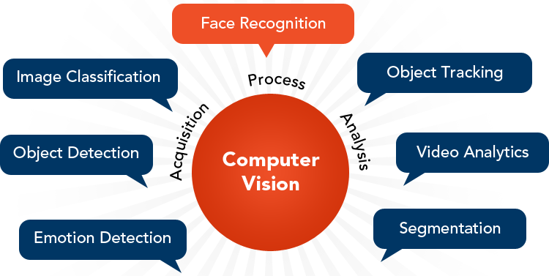

There is a lot of [research](https://research.ibm.com/artificial-intelligence/computer-vision/) being done in the computer vision field, but it’s not just research. Real-world applications demonstrate how important computer vision is to endeavors in business, entertainment, transportation, healthcare and everyday life. A key driver for the growth of these applications is the flood of visual information flowing from smartphones, security systems, traffic cameras and other visually instrumented devices. This data could play a major role in operations across industries, but today goes unused. The information creates a test bed to train computer vision applications and a launchpad for them to become part of a range of human activities:

* IBM used computer vision to create My Moments for the 2018 Masters golf tournament. IBM Watson watched hundreds of hours of Masters footage and could identify the sights (and sounds) of significant shots. It curated these key moments and delivered them to fans as personalized highlight reels.
* Google Translate lets users point a smartphone camera at a sign in another language and almost immediately obtain a translation of the sign in their preferred language.[(6)](https://www.ibm.com/topics/computer-vision#citation6)
* The development of self-driving vehicles relies on computer vision to make sense of the visual input from a car’s cameras and other sensors. It’s essential to identify other cars, traffic signs, lane markers, pedestrians, bicycles and all of the other visual information encountered on the road.
* IBM is applying computer vision technology with partners like Verizon to bring intelligent AI to the edge, and to help automotive manufacturers identify quality defects before a vehicle leaves the factory.

**WHAT IS GOOGLE COLAB:**

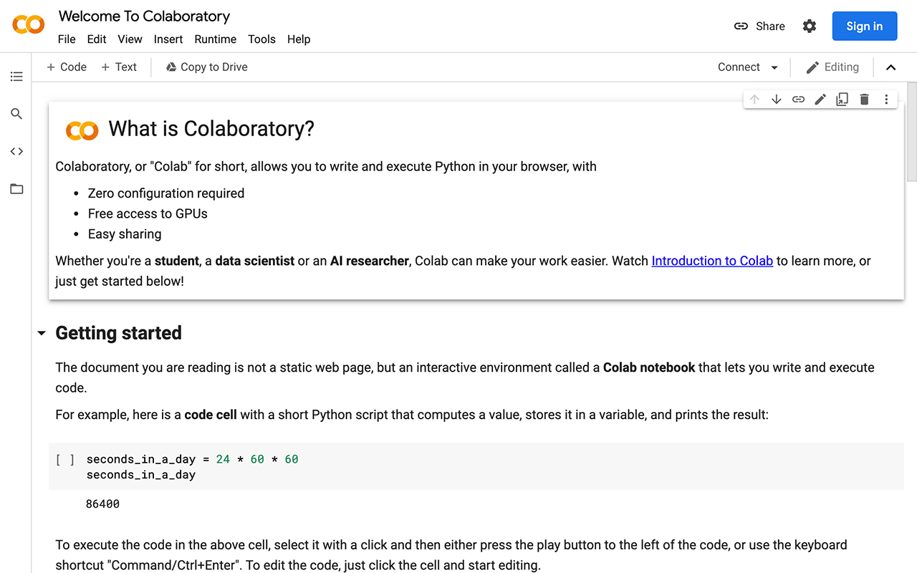

To be precise, Colab is a free Jupyter notebook environment that runs entirely in the cloud. Most importantly, it does not require a setup and the notebooks that you create can be simultaneously edited by your team members - just the way you edit documents in Google Docs. Colab supports many popular machine learning libraries which can be easily loaded in your notebook.

**WHAT IS YOLOV3:**

YOLOv3 (You Only Look Once, Version 3) is a real-time object detection algorithm that identifies specific objects in videos, live feeds, or images. YOLO uses features learned by a [deep convolutional neural network](https://viso.ai/deep-learning/deep-neural-network-three-popular-types/) to detect an object. Versions 1-3 of YOLO were created by Joseph Redmon and Ali Farhadi.

The first version of YOLO was created in 2016, and version 3, which is discussed extensively in this article, was made two years later in 2018. YOLOv3 is an improved version of YOLO and YOLOv2. YOLO is implemented using the Keras or OpenCV deep learning libraries.

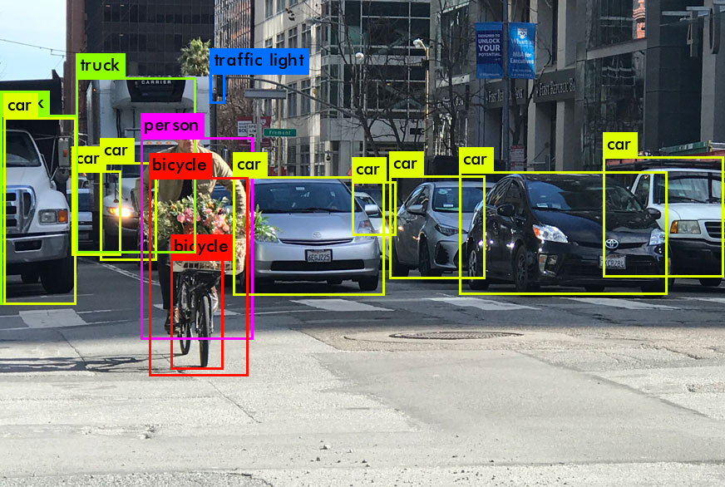

Object classification systems are used by Artificial Intelligence (AI) programs to perceive specific objects in a class as subjects of interest. The systems sort objects in images into groups where objects with similar characteristics are placed together, while others are neglected unless programmed to do otherwise.

**WHAT IS DEEP LEARNING AND CNN:-**

**Deep Learning** is a subfield of machine learning concerned with algorithms inspired by the structure and function of the brain called **artificial neural networks**.

If you are just starting out in the field of deep learning or you had some experience with neural networks some time ago, you may be confused. I know I was confused initially and so were many of my colleagues and friends who learned and used neural networks in the 1990s and early 2000s.

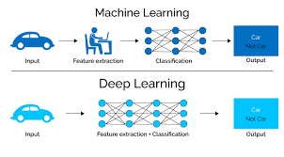

Deep learning eliminates some of data pre-processing that is typically involved with machine learning. These algorithms can ingest and process unstructured data, like text and images, and it automates feature extraction, removing some of the dependency on human experts. For example, let’s say that we had a set of photos of different pets, and we wanted to categorize by “cat”, “dog”, “hamster”, et cetera. Deep learning algorithms can determine which features (e.g. ears) are most important to distinguish each animal from another. In machine learning, this hierarchy of features is established manually by a human expert.

**CNN:**

A convolutional neural network (CNN) is a type of [artificial neural network](https://searchenterpriseai.techtarget.com/definition/neural-network) used in [image recognition](https://searchenterpriseai.techtarget.com/definition/image-recognition) and processing that is specifically designed to process pixel data.

CNNs are powerful image processing, artificial intelligence ([AI](https://searchenterpriseai.techtarget.com/definition/image-recognition)) that use deep learning to perform both generative and descriptive tasks, often using machine vison that includes image and video recognition, along with recommender systems and natural language processing ([NLP](https://searchbusinessanalytics.techtarget.com/definition/natural-language-processing-NLP)).

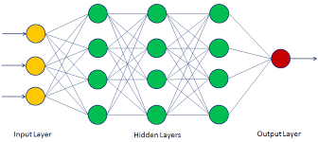

Fig: Neural Network.

A neural network is a system of hardware and/or software patterned after the operation of neurons in the human brain. Traditional neural networks are not ideal for image processing and must be fed images in reduced-resolution pieces. CNN have their “neurons” arranged more like those of the frontal lobe, the area responsible for processing visual stimuli in humans and other animals. The layers of neurons are arranged in such a way as to cover the entire visual field avoiding the piecemeal image processing problem of traditional neural networks.

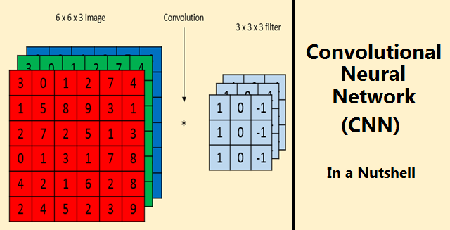

A CNN uses a system much like a multilayer [perceptron](https://whatis.techtarget.com/definition/perceptron) that has been designed for reduced processing requirements. The layers of a CNN consist of an input layer, an output layer and a hidden layer that includes multiple convolutional layers, pooling layers, fully connected layers and normalization layers. The removal of limitations and increase in efficiency for image processing results in a system that is far more effective, simpler to trains limited for image processing and natural language processing.

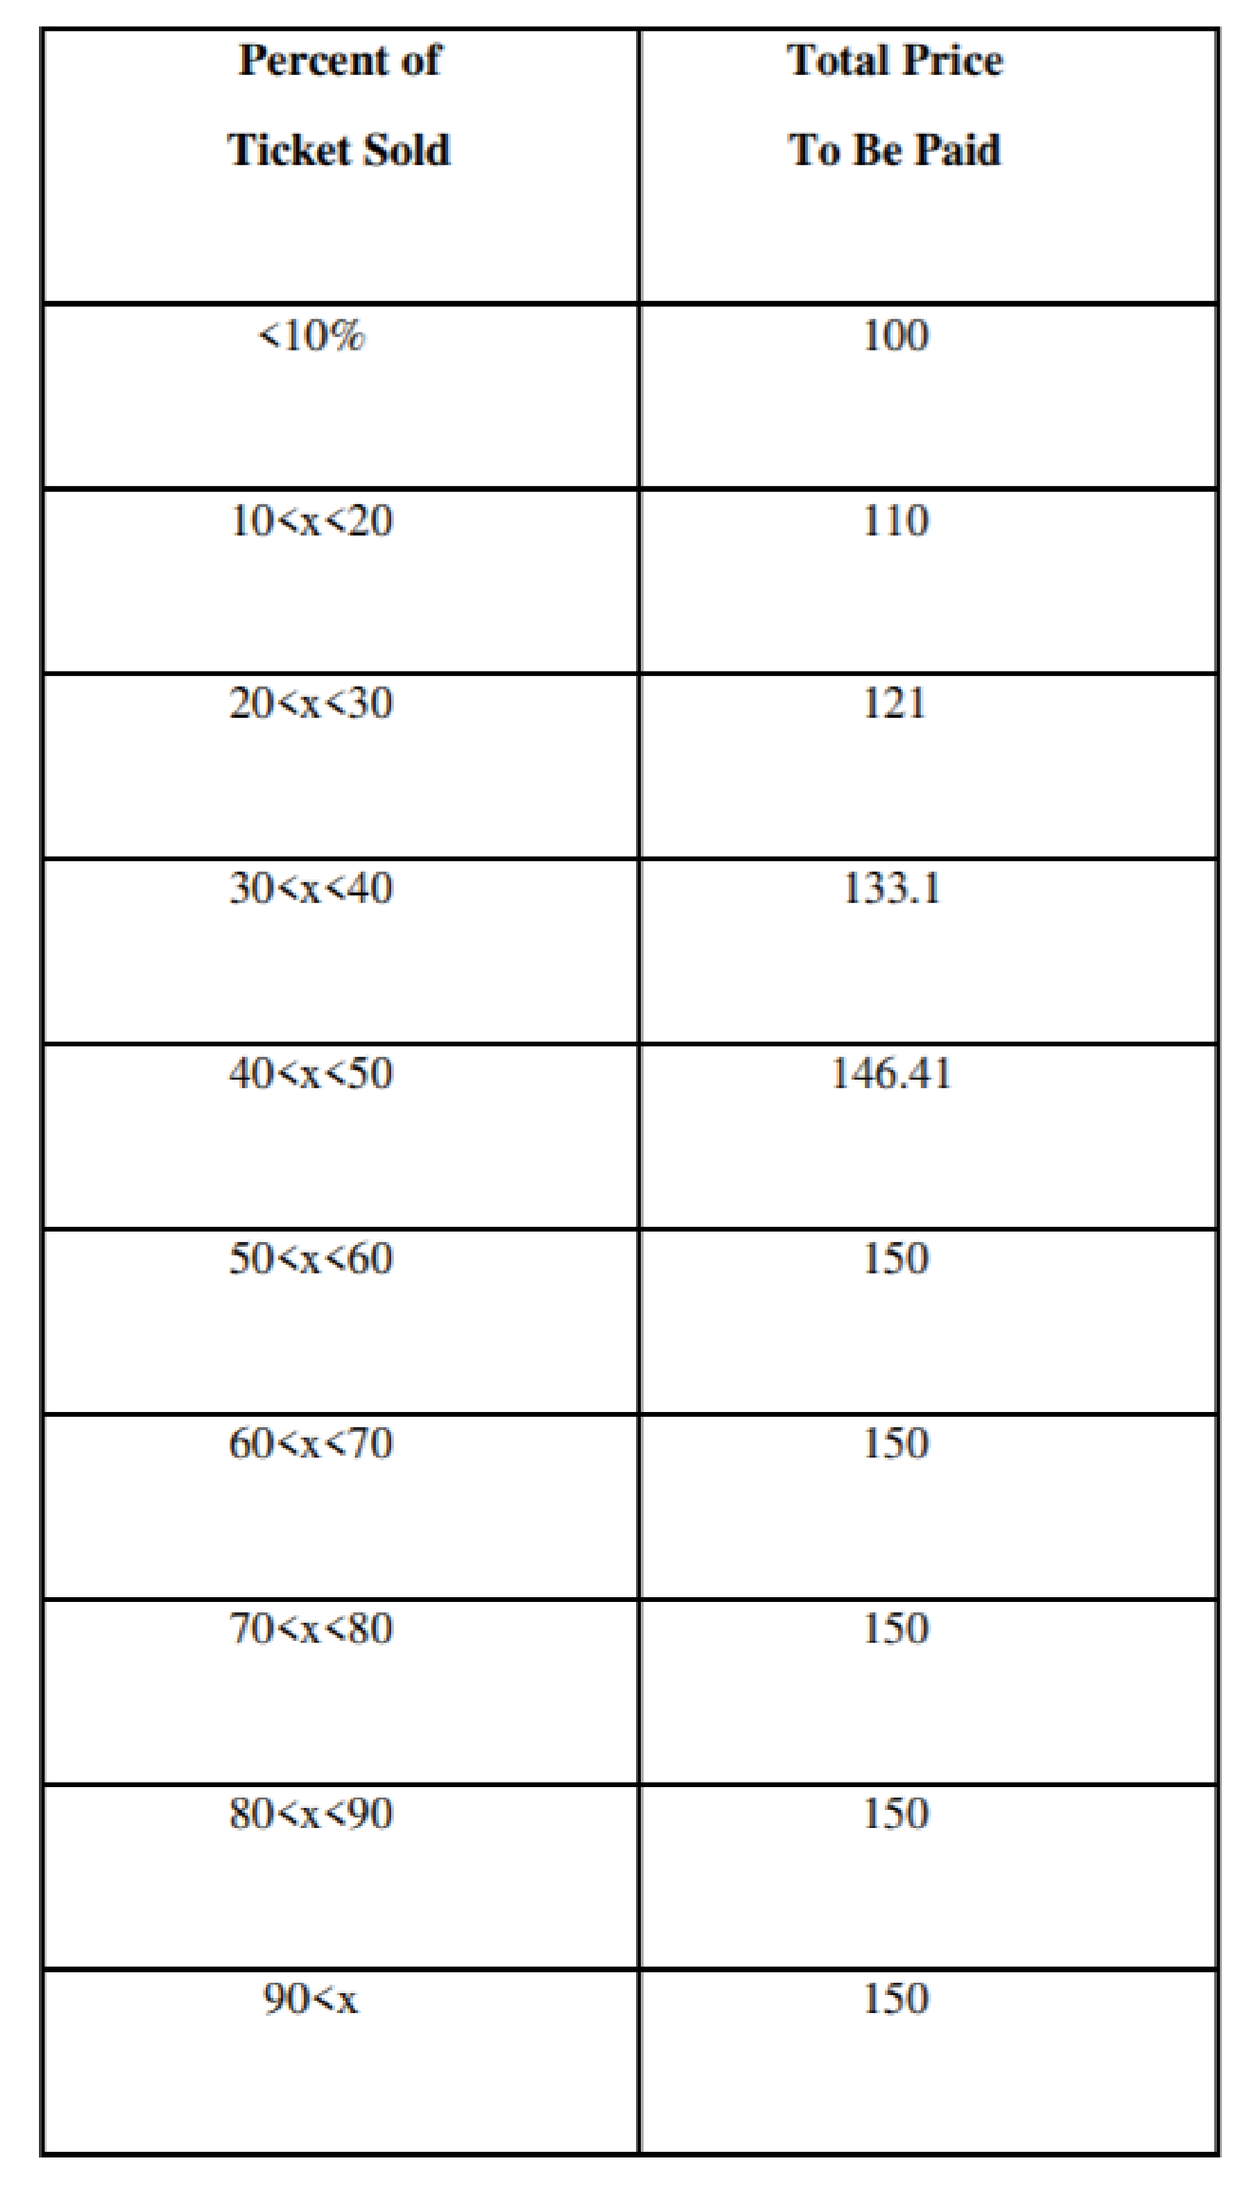

**HOW DOES ML/AI BENEFITS FASHION TECH:-**

Once the clothes are designed, AI technologies can also play a role in textile manufacturing. Fashion manufacturers are innovating the use of AI to help improve efficiency of manufacturing processes and augment human textile employees. AI systems are being used to spot defects in fabric and ensure that the colors of the finished textile match with the originally designed colors. AI technologies such as computer vision technologies are allowing quality assurance processes to be more streamlined.

Machine learning technologies are also being applied to expediting logistics and making the supply chain more efficient. AI is being used to manage and optimize supply chains as well as reduce shipping costs and transit time. Machine learning algorithms are being used to make more accurate predictions of inventory demand and therefore reduce wastage or eliminate last minute purchases to meet unexpected spikes in demand.

Computer vision enabled by machine learning is also being used to help spot fashion fakes and counterfeit products. Previously, spotting fakes required the trained eye of specialized customs or other enforcement officers. Now, AI systems can keep a consistent watchful eye on counterfeit products that look increasingly similar to the real ones. In this area, AI technologies are being applied by customs and border enforcement to help spot the validity of high-end products which are frequently counterfeited such as purses and sunglasses.

**CONCLUSION**

Running the model is like a nightmare as it takes into consideration lot of variables and railways is the one of the most important factor in running an economy. The basic idea of the algorithm is to find the sweet spot. If they charge too much, they will lose potential customers. If they charge too little, they may be able to fill up the seats, but the profit margin will be thin (worse case, they end up making a loss). Indian Railways model may never hit the upper limit because it is for the people and it is a government owned entity. Even though there are shortcomings and inefficiencies, in the model, it is a great step for the betterment of the Indian Railways and it is high time people stop taking it for granted. With more revenue coming in it will offer better facilities and service to the passengers.

Note: The process of algorithm building and observations have been kept confidential as per the NDA*

CERTIFICATE OF COMPLETION

Please find the attached image of the certificate:

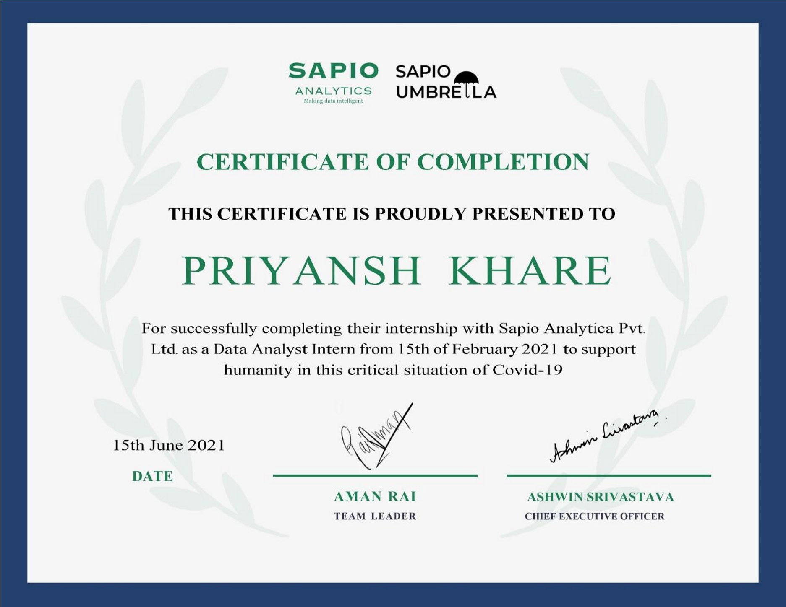

LETTER OF COMPLETION

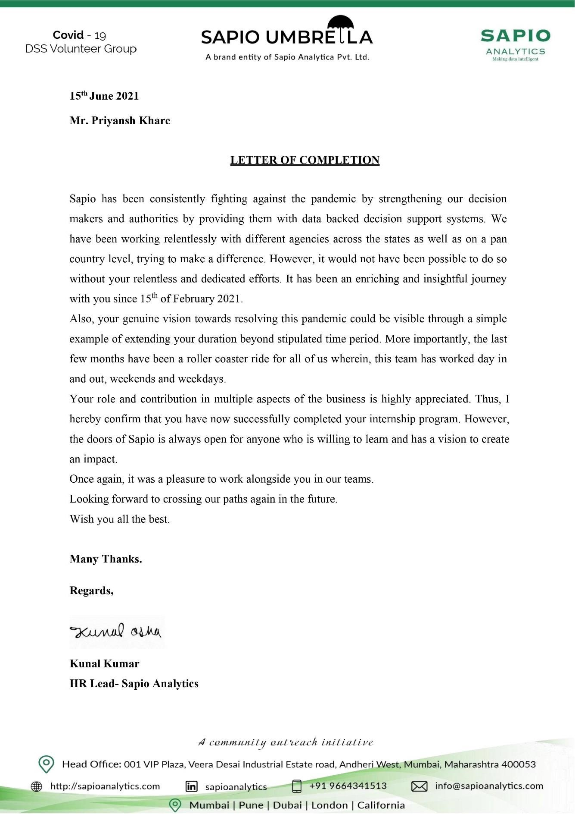

CONCLUSION

Through my internship at Sapio Analytics Pvt. Ltd., I was able to get a better understanding on the use of various technology like Python, OOPS, Microsoft Excel, Research, Data Simulation, Statistics tools & how effective they are in transforming real life industry problems.

Through my project at the firm, I was able to understand the importance of case analysis & implementing learnt technology under different circumstances & conditions.

I also gained a lot of personality skills as time passed by working at the firm.

Overall, it was really a very great experience in being a part of the Sapio Umbrella!

Thank you.

Regards

Priyansh Khare

B. Tech. – Semester: 6

1802017

Department of Electrical Engineering

National Institute of Technology Patna